SOUTH CENTRAL SHRINE ASSOCIATION MOTOR CORPS
COMPETITION RULES

ELIGIBILITY and HELMET USE

All members Corps of the South Central Association of Shrine Motor Corps in good standing and in compliance with Article IV of the South Central Association of Shrine Motor Corps Bylaws.

Contestants must wear a DOT approved helmet when operating their vehicle in all SCASMC events unless an exception is made by the Director of Competition.

In the event that only a single member of a unit which is a member in good standing of the SCASMC shows up for the competition, he may participate in the obstacle course and slow race. However, these scores are not factored into any team scores.

DIVISION OF VEHICLES
The division of vehicles for the Drill Competition & Obstacle Course shall be:

Two wheel classes shall consist of Small (0 to 250cc), Medium (251 to 900 cc), and Large (901cc and up).

3 wheel classes shall consist of Modified (Drift trike and such), Small (Honda types and such), and Large (Full size Motorcycle type Trikes).

4 wheel unit classes shall consist of: Antique Cars (Tin Lizzie types), Small (0-300cc), and Large (300cc and up).

Miscellaneous class will consist of any unit regardless of number of wheels, size, or cc’s that doesn’t fit in the above classes such as scooter type ice chests, motorized recliners, planes and such.

If only one vehicle class is entered in any of these cc classes, then said unit can be placed in the nearest CC class at the direction of the Director of Competition. Classes shall be the same for Drill Competition and Obstacle Course. Slow ride will be a combination of all two wheel classes.

COMPETITIVE DRILL COMPETITION
Drill competition will consist of an inline inspection and a competitive field drill as described in A and B below.

A: Inline Inspection
The first part of Competitive Drill involves the line inspection. Each Unit must line their vehicles and personnel on the assigned inspection line for a military type inspection. The judges will inspect only four vehicles and personnel and make deductions for infractions according to the score sheet. They will be looking for things like neatness, cleanliness, uniformity, and presentation of Unit.

Inspection Rules
Any Motor Corps Unit failing to report to the "inspection line" at the scheduled time will be penalized four (4) points.

Four vehicles and personnel will be judged on the inspection line only. Units must have all vehicles and personal that are participating in Competitive Drill on the inspection line. No one will know which vehicles or personal will be inspected. This will be determined by the judges at the inspection line. Judges shall have absolute privacy during the contest and shall not be approached by anyone except members of the Competition Committee.

One judge will score personal appearance of each member and one judge will score the vehicle being used. Fez must be worn during inline inspection and be worn according to Shrine Imperial By-Laws. (Refer to score sheet)

B: Drill Competition
Immediately following the line inspection, the Unit must proceed to the drill field for their drill maneuvers. The drill area is a field 150'x300' where each Unit must perform their maneuvers. There are no required or mandatory drills. Each Unit is allowed to create their own drill. Each Unit must be on the field at least 5 minutes, but no longer than 10 minutes. Four judges will deduct points for infractions according to the score sheet. They will be judging for posture, ease of handling, interval and distance, rider error (foot down, falling over etc.), variety of drills, execution of drills, and difficulty of maneuvers. Upon competition of their drill, as each Unit leaves the field, the leader must stop his vehicle before the painted safety line.

Competitive Drill Rules
The competition area shall be hard surface, 150'x 300' and the convention chairman shall notify all Motor Corps Units of any change at least 30 days in advance.
The Directors of Competition shall have complete charge and control of all matters pertaining to the competitive drills.

Before the competition begins, the Captain or President of each Motor Corps Unit shall certify that all his members’ dues are paid.

There shall be no limitation as to size of any Motor Corps Units participating in the drill competition. No other corpsman may participate with any other Motor Corps Unit, other than his own. All Motor Corps Units, drill masters, colors, and or standards, taking part in this contest are subject to judging and all other requirements including Motor Corps membership.

The Judges, who will judge the drill competition will be instructed by the Directors of Competition of the Motor Corps on how to make their inspections and explain the score sheets and method of scoring. There will be a minimum of two judges to score the inline inspection and four judges to score the maneuvers.

All Motor Corps Units will begin the competition with one hundred points and shall lose points for infractions. All four judges on the drill fields shall score all aspects of the score sheets, except judge #1 will be the only judge to score the time on and time off the field.
The scores of all four judges will be added for a total and averaged for a final score.

Each Motor Corps Unit entering competition will be allowed not less than five nor more than ten minutes on the field and will be penalized for violations of this rule. Judges shall use stop watches. Timing and judging will begin when the last man enters the field and will stop when the first man leaves the field. Three points will be subtracted for overtime or undertime on the field.

No scores will be announced until the time of the awards banquet. Trophies will be presented to the first, second, and third place winners. In the event of a tie, two trophies shall be presented. A committee of three Past Presidents shall be appointed to award all trophies not covered by these rules.

Any Motor Corps Units who allows any member to participate without having first paid dues for such member will be disqualified.

All members of all motorized units shall stand inspection in their Fez and use helmets for the Drill. Helmets do not have to be identical, and no judging will be done on helmets

SAFETY RULE
A white line shall be placed 20 feet or less outside the entrance/gate of each competitive drill field. All drill units must come to a complete stop on or before reaching this line after drill is completed or be disqualified.

Lineup
Lineup for vehicles type and unit order will be determined by drawing at the Unit Motor Corps meeting during the S.C.S.A. Convention the day before competition.

SCORING FOR HIGH POINT TROPHY (Amended and approved, February 5, 2000) Points for the high point trophy shall be awarded only for the Inline Inspection and Competitive Drill. No other competition shall be used to determine points towards the high point trophy winner.

OBSTACLE COURSE
Individuals may compete but will only be considered for fastest or slowest trophies. Each member Unit may enter into the Obstacle Course and may enter as many vehicles as they wish into the Obstacle Course in whichever class they fall into. The classes in the Obstacle Course are the same as the Competitive Drill classes. The object is to complete the course in as fastest time as possible, without leaving the course, and stopping the front wheel of your vehicle in a set stopping area. The course has small cones outlining the course with painted directional arrows on the path of the course. The two fastest times of the Unit are combined for a total score of the Unit. Trophies are awarded for 1st place in each class.
It is to the Unit's advantage to ride as many riders as possible. This way, if any rider does not complete the course, or does not stop in the stop box, and is disqualified, the unit still has several scores that can be used. There is no inspection required on the Obstacle Course, except that the Officer in charge of each course may verify your proper classification.
Some Units are composed of vehicles that may fall into more than one Obstacle Course or Competitive Drill class. There is no rule prohibiting the unit from entering more than one class, but they must have at least two riders per class for a team score.

OBSTACLE COURSE RULES
The Obstacle Course will be a timed course and each competitor will be timed individually.
All members of a motorized unit and are members of SCASMC may ride the Obstacle Course.
The same vehicle cannot be used by two contestants. Each rider must have his own vehicle and it must be the same vehicle used in Competitive Drill, if he competed.
Any motorized unit that is a member of SCASMC may compete on the Obstacle Course, regardless of whether the unit participated in Competitive Drill or not.
Any unit that desires to compete on the Obstacle Course must present at least two competitors who must complete the course satisfactorily for a score as the two fastest times will be added together for a unit score.
No contestant may ride the Obstacle Course for practice before the start of competition. Anyone doing so will be disqualified. However, the course may be walked when the judges give permission.
While the rider is on the course, he must follow the course as it is designed and if he runs out of the designed course, he must re-enter the designed course at the same point as he ran off the designed course and continue the course. If the rider fails to re-enter the course at the same place as he exited the course, this rider is disqualified.
Each time a riders foot touches the ground or knocks a cone down or moves it out of position to the point that it must be re-set, a one second penalty will be added to the riders score for each of the individual infractions.
At the end of the designed course there will be a "stop" line. The timer will stop the time of the ride at this point. There will be a "safety" stop line thirty-six inches after the "stop" line and each rider must stop with his front wheel within this area or this rider is disqualified.
Judges shall have absolute privacy during the contest and shall not be approached by anyone except members of the Competition Committee. Any interference, or anyone gathering around the score table to see the times will cause an automatic disqualification of the unit. No score will be announced prior to the Awards Banquet. The Decisions of the judges shall be final

SLOW RIDE
The Slow Ride Course is a form of Competition for two wheel vehicles only. It is a set course where the object is to take as long as possible to complete the course. The course is 30'x30’ with a 20' line down the middle which will give the rider an entrance gate 15' wide, an exit gate 15' wide and a reverse direction gate 10' wide. Your time starts when your front wheel crosses the entry line. Your time stops when:
1. Your front wheel touches any other line
2. Your foot touches the ground
3. Your wheel makes a movement toward the entry gate. (this prevents a rider from riding around in circles) There is no disqualification to this Competition. Your time simply starts when you enter and stops at any infraction.

Any Unit may enter as many members as they want to ride the course.

An individual trophy is awarded to the individual who has the longest ride of the day

All two wheel classes will be combined.

The combined time of the two best riders shall be the team score for the unit.

The same motorcycle cannot be ridden by two contestants.

DIVA DERBY
The Diva Derby will be conducted on the same obstacle course and follow the same rules as the other obstacle course classes and will be open to any registered Lady of SCSA. The only authorized vehicle will be furnished by the SCASMC.

TROPHIES
Team trophies will be presented as follows; First, Second, and Third place for the Drill Competition. First Place team trophies for all classes in the Obstacle Course and the Slow Ride, First Place Trophy for Fastest Man on Two, Three, Four wheels, Slowest Man on two wheels, First Place Diva Derby and the Traveling High Point Trophy. Due to the large number of trophies and the associated cost, trophies will be ordered based on timely unit entries. So, any unit not sending in an entry form stating the classes they will compete in within 45 days prior to the competition will still be allowed to compete but may not have a trophy for the class they enter.

SAFETY
Helmets will be worn by two wheel units at all times to include the Drill, Obstacle Course, and Slow ride competitions with the exception of when they are standing for inspection. Multi wheel units will wear helmets for the Obstacle Course and are encouraged to wear them for the Drill Competition as well.

INCLEMENT WEATHER (Added and approved, February 5, 2000) If rain occurs the night before competition, the president shall make arrangements to sweep and dry the competition field. If drizzle starts after competition has started, the secretary and director of competition shall decide if it is safe to continue competition. In the case of a downpour, the competition will be halted and rescheduled at the convenience of the secretary and director of competition during the convention. If a unit is on the field, the captain of the unit may signal his unit cannot continue. This unit will be first on the field and all other units will follow by the order of the draw when the drill competition is restarted. No penalty will be assessed towards any unit because of the rainout.

PARTICIPATION IN COMPETITION BY OFFICERS (Added and approved February 8, 2002) elected officers of the South Central Association of Shrine Motor Corps may participate in the competition events provided that they are not judging the competition units. The tabulation of scores is not considered judging.

AMENDMENTS
These Rules may be amended at any Mid-Winter or Annual Meeting of this Association by two thirds vote of the majority of those present and qualified to vote.

Obstacle Course

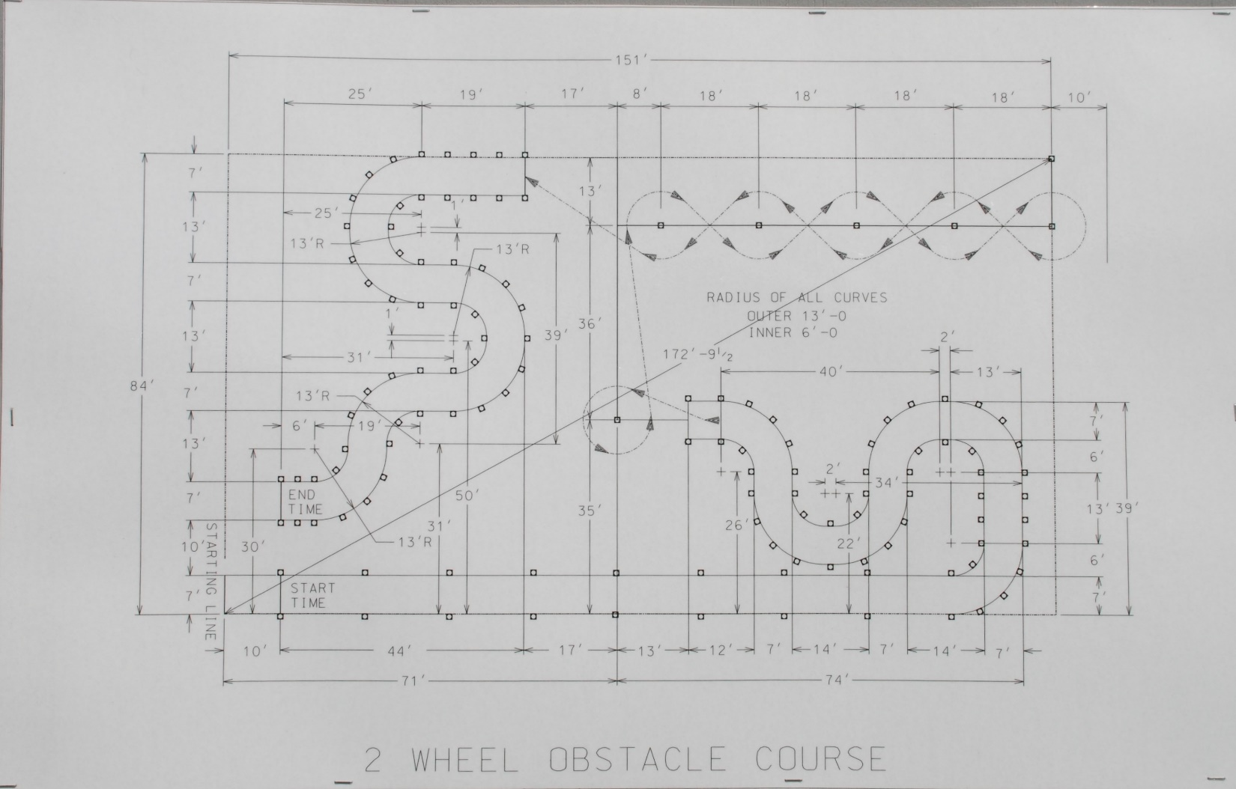

Slow Ride Box
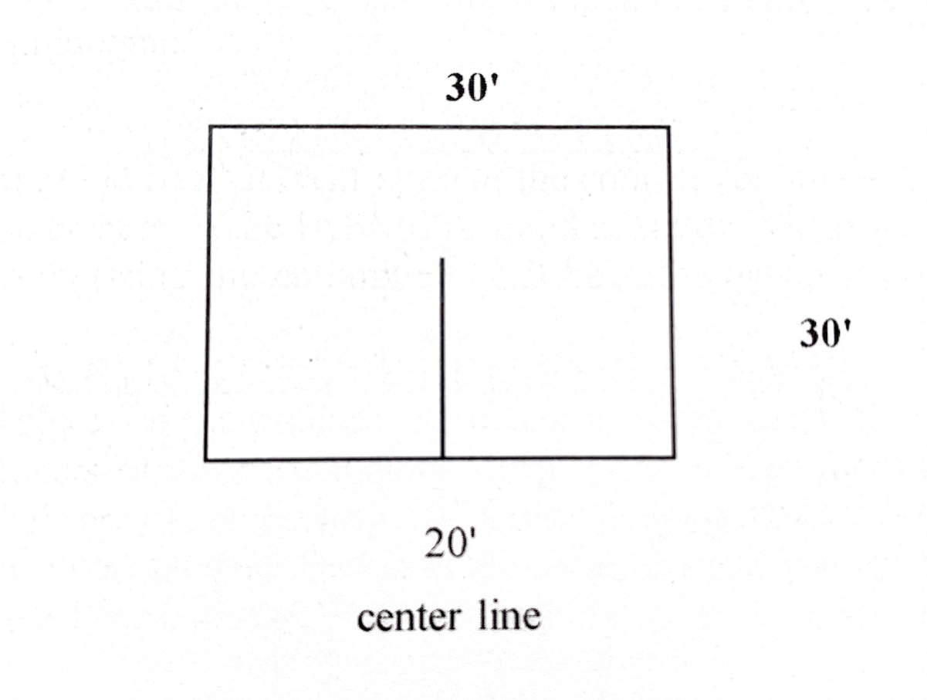

Drill Field Layout

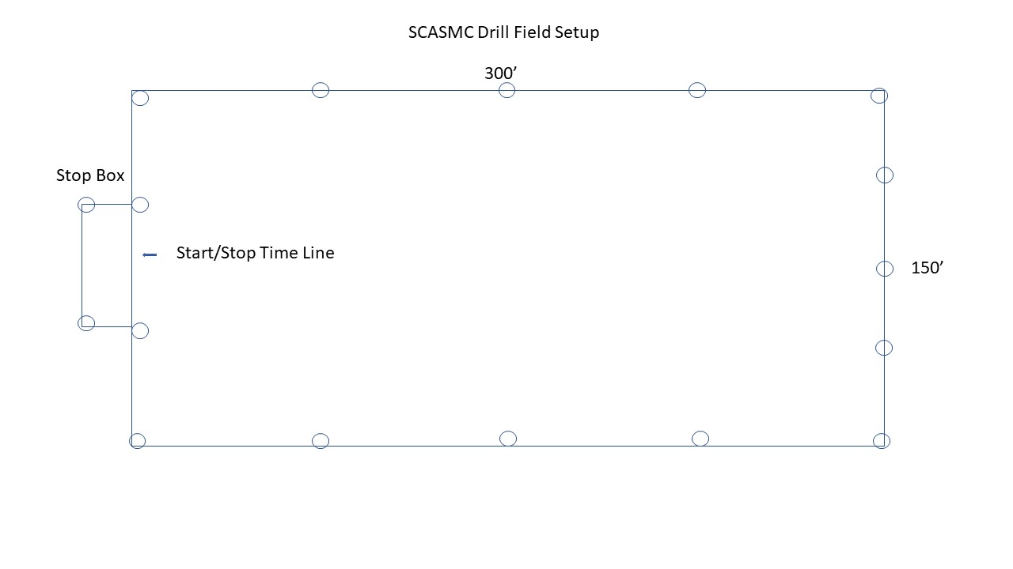
INLINE SCORE SHEET

SOUTH CENTRAL SHRINE ASSOCIATION - MOTOR CORPS

CONVENTION HOST: DATE
LOCATION:

Starting Order: _________ VEHICLE TYPE:

UNIT:____________________________ 2W____3W____4W____HP____CC____

TEMPLE:____________________________ NUMBER OF SHRINERS FOR INSPECTION:_______ VEHICLES:_______

A: UNIFORMS:
 | POSSIBLE POINTS | SCORE | JUDGES REMARKS
1. NEATNESS | 0 to 5
2. GENERAL APPEARANCE | 0 to 5
3. TILT OF FEZ | 0 to 5
TOTAL POINTS | 15
B. EQUIPMENT:
 | POSSIBLE POINTS | SCORE | JUDGES REMARKS
1. CONDITION | 0 to 5
2. GENERAL APPEARANCE | 0 to 5
TOTAL POINTS | 10

DESCRIPTION OF INLINE POINTS

A. UNIFORMS:

1. Neatness Uniform is to be clean with no dust, dirt, grease, or grime thereon. Boots or shoes are to be cleaned, shined, and the same color. Uniform is to be properly worn, in good condition, not ragged or worn.

2. General Uniforms are to be alike and worn in the same manner. Includes boots, shoes, pants, shirts, ties, Appearance shoulder cords, or other decorations used on the uniform. Conference Badge MUST be worn.

3. Tilt of Fez Fez is to be worn square on the head, not tilted to either side, forward or backwards, must be clean.
The title on the Fez my vary.
B. EQUIPMENT:

1. Condition Vehicle should be clean, free of dust, dirt, mud, excess oil, and oily grime. Chrome polished, no rust on equipment, no paint chips or pealing, and in good working order. Models or colors may vary.

2. General The total look of a unit, vehicles, riders, flags, and other items used to make the unit look sharp.
Appearance

FIELD COMPETITION SCORE SHEET

SOUTH CENTRAL SHRINE ASSOCIATION - MOTOR CORPS

CONVENTION HOST: DATE
LOCATION:

STARTING ORDER:_______ VEHICLE TYPE:

UNIT:__________________________ 2W____3W____4W____HP____CC______
TEMPLE:__________________________

Timer _____ Start on time Y N Time on Field ________________ End on time Y N

Judge # 1 ____ Judge # 2 _____ Judge #3 ____ Judge #4 ____

Note: Each Judge may show Plus and / or Minus Points in ALL boxes, within the Range shown.
Base Points Plus Points Minus Points Total
1. Riding Posture | 3 | 0-3 (Range)  --------- | 0-3 (Range)  ---------
2. Ease of Handling | 3 | 0-3  --------- | 0-3  ---------
3. Interval & Handling | 3 | 0-3  --------- | 0-3  ---------
4. Rider Error, Stalls | 7 | 0-6  -------- | 0-6  ---------
5. Variety of Drills | 5 | 0-4  --------- | 0-4  ---------
6. Execution of Drills | 8 | 0-7  --------- | 0-7  ---------
7. Maneuver Difficulty | 6 | 0-6  --------- | 0-6  ---------
Comments:

(To be completed by Scorekeeper, after competition) GRAND

Scorekeeper: For each line, Add Base, Add Pluses, Subtract Minuses. TOTAL:________

